Guitar pentatonic highway

There is a road that every guitar player must travel down on their way to six string mastery. That road’s name is:
The Pentatonic Super Highway !!!
Okay, it’s not so much a road as it is a pathway through a scale you probably already know, The Major/Minor Pentatonic scale.Playing the scale in this way removes the large stretches and organizes the notes in a way that is easy to grip, slide and bend.So what could be better than having a pentatonic super highway to jam on…well having two of course, and between the two of them you can cover the entire neck.Lets take a look at how these shapes fit into the overall pentatonic scale & how to play them.

The Pentatonic Super Highway Ascending
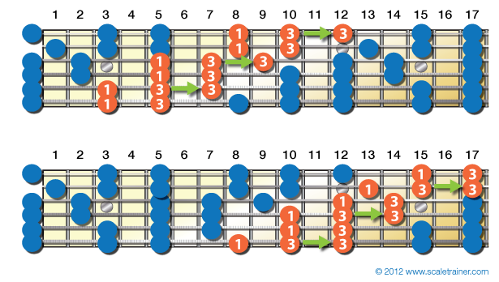
Typically players will use their third finger to do the slides when going up the scale and their first finger when traveling down. As with any “rule” though experimentation is encouraged, and it may lead you to some cool licks as a result.

The Pentatonic Super Highway Descending
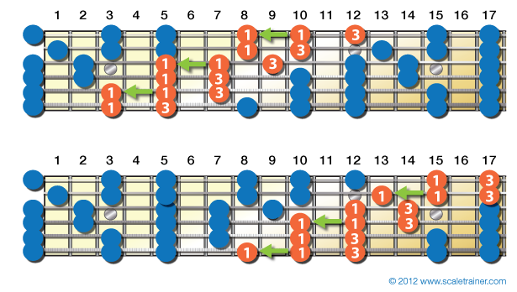

Practice Exercise Here’s an exercise to help you practice the two shapes. It ascends the neck using one shape and descends the neck using the other. Now get out on that highway and do some traveling.
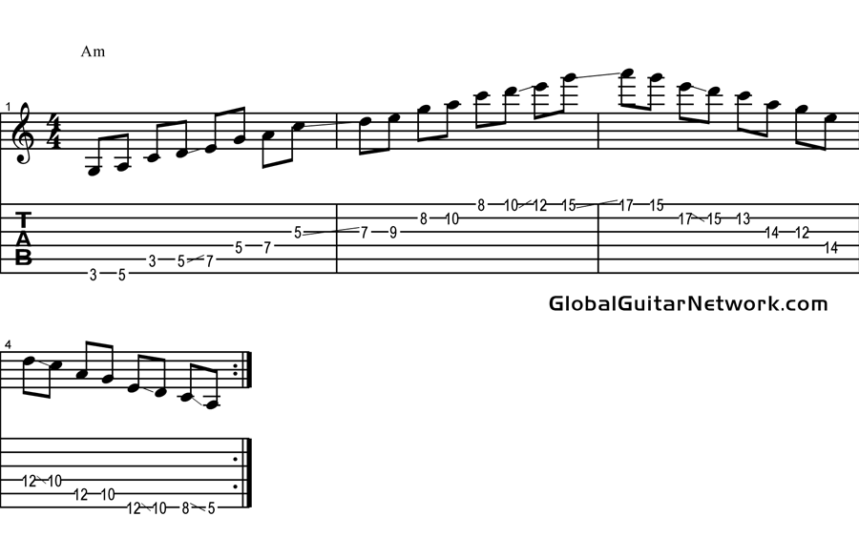

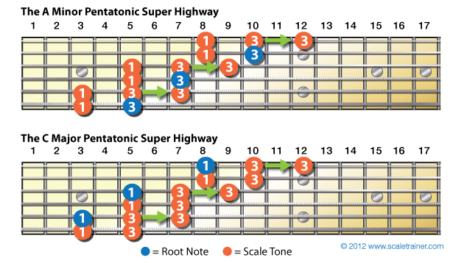
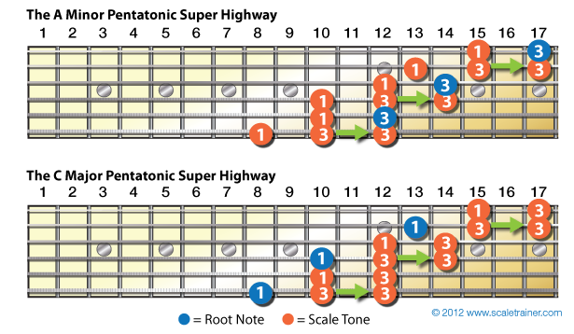
In the example below the PSH is played over an A minor chord to bring out its minor qualities and then over a C major chord to bring out its major qualities. If you’d like to learn more about relative major and minor keys click here.

